# FoodFans APP设计文档

## 组长:杨鹏勃

## 组员:张耀文，陈灼

**文档编写人:张耀文**

1. **引言**

为适应市场需求，满足顾客方便快捷的搜索到优秀餐饮，快速浏览菜品相关详细信息，本项目计划开发大众美食点评APP，该APP将会满足顾客的食品搜索，食品点评，店家搜索等需求。

**1.1编写目的**

本节描述软件详细设计文档的目的是：

定义软件总体要求，作为用户和软件开发人员之间互相了解的基础；

作为软件总体测试和系统结构设计的依据；

本文档的预期读者包括：软件设计人员、模块开发人员、管理人员、测试人员。

**1.2项目背景**

项目名称:FoodFans；

项目提出者:曾立刚；

开发者:杨鹏勃，陈灼，张耀文；

**1.3定义**

MYSQL：一种免费的功能较强的数据库管理系统

Android Studio：基于IntelliJ IDEA. 类似Eclipse ADT，Android Studio 提供了集成的 Android 开发工具用于开发和调试。

1.4技术路线：retrofit+room+recyclerview+gridview+listview+livedata

后端：springboot+mybatis+jwt(token验证）

1. **总体设计**

## 2.1用例图

本产品分为多个模块，具体用例图如图一

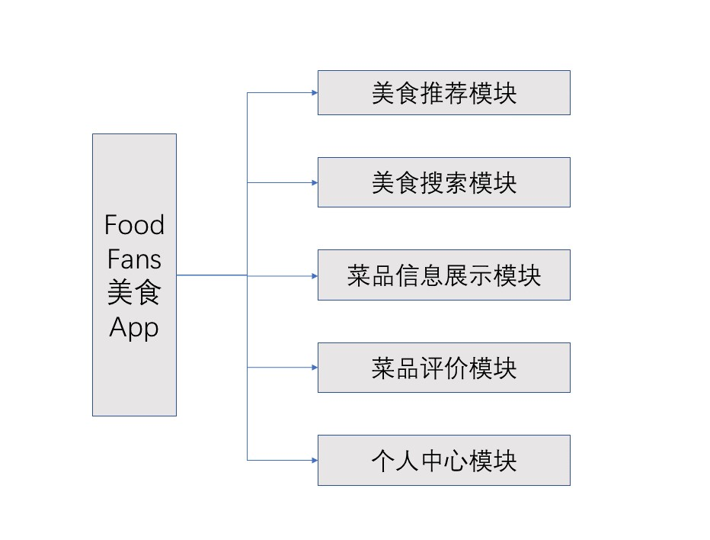

图1 FoodFans APP用例图

## 2.2需求规定

本系统为了满足顾客便捷的餐饮评价与搜索功能，需要完成菜品分类浏览，菜品详细信息展示，菜品评价，用户个人中心等操作，具体功能描述如表一:

表1 FoodFans APP功能详细

|  |  |
| --- | --- |
| 功能项 | 详细描述 |
| 菜品信息分类浏览 | 在APP的“发现”栏中，数据库中所有菜品信息按照菜系分类展示，该界面仅展示菜品概览图，菜品名称，菜品菜系； |
| 主页菜品推荐 | 在APP“主页”栏中展示系统每日自动推荐菜品，顾客可选择感兴趣的菜品点击进入详细信息界面； |
| 菜品详细信息 | 为菜详细信息展示界面，包括菜品评分，来源商家，口味，价格，商家地址，菜品简介，相关评论。用户可在详细信息界面点击爱心收藏菜品 |
| 菜品评价体系 | 顾客可对菜品进行评分以及评论。评分系统为五级制，使用星级表示，也可显示具体评分，具体评分为根据所有评价顾客的总体评分记过算法计算得出。评论体系为顾客可通过具体评论，详细描述菜品体验； |
| 登录，注册模块 | 用户需登录才可使用APP功能，用户可通过登录界面上的“注册”按钮进入注册界面进行注册，注册信息会存入数据库中； |
| 用户中心模块 | 在APP“我的”界面中可查看用户中心，用户可在用户中心设置，查看头像，名称。用户可在个人中心“我的收藏”中查看已收藏菜品 |

## 2.3全局变量

****

## 2.4运行环境

Android系统；

MySQL数据库；

## 2.5开发工具

Androidstudio

# UI设计

## 3.1菜品**推荐**界面

### 3.1.1界面简介

主页展示系统菜品推荐，包括菜品缩略图，菜品名称，推荐菜品为系统从数据库中随机选取

### 3.1.2界面展示

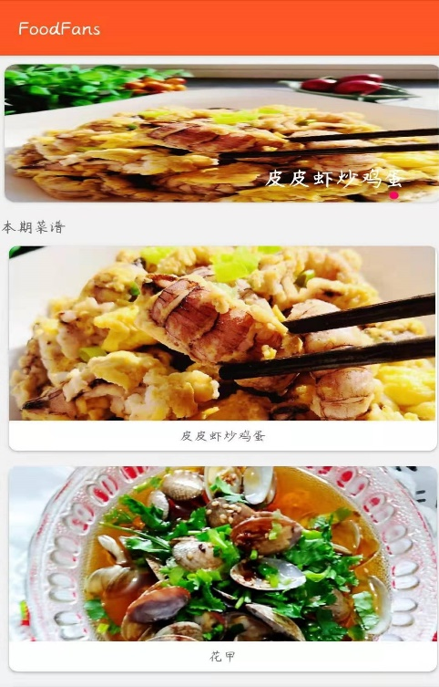

## 3.2菜品分类搜索

### 3.2.1界面简介

在“发现”栏中展示数据库中所有菜品。菜品按照不同菜系分为栏目展示，顾客可通过点击菜系名称查看不同菜系的菜品。

### 3.2.2界面展示

## 

## 3.2菜品详细信息展示界面

### 3.2.1界面简介

当用户在推荐界面或菜品发现界面点击菜品缩略图，可跳转进入菜品详细信息界面。详细信息界面分为详情与评价界面。详情界面展示菜品对应的商家，口味名称，价格，地点，菜品简介等内容。评价界面展示所有用户对该菜品评价，包括文字内容与评分星级。该界面点击收藏按钮收藏菜品。

### 3.2.2界面展示

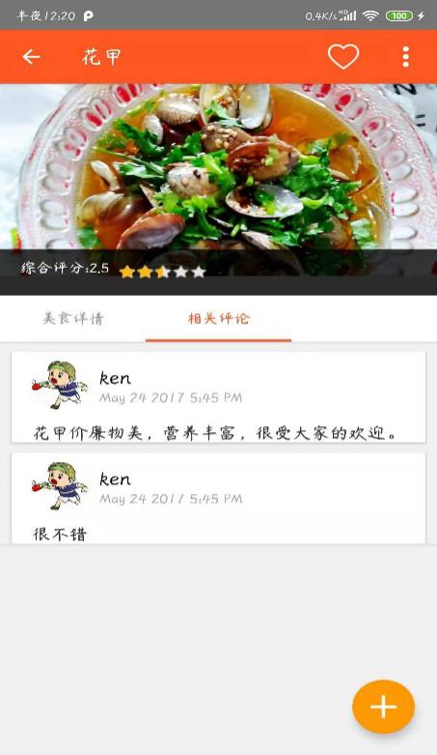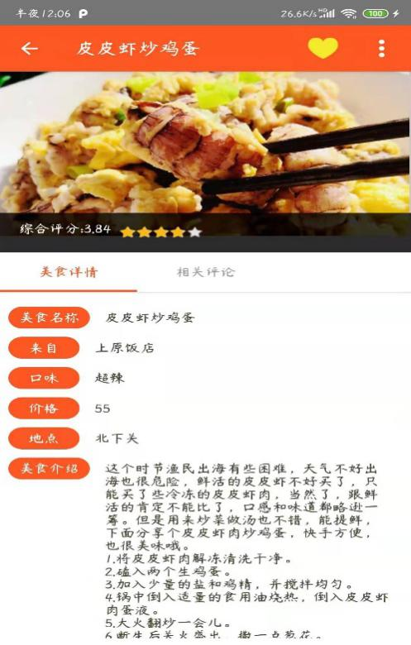

## 3.3菜品评价界面

### 3.3.1界面简介

用户可详情界面点击进入评价界面，对菜品选择星级，输入文字进行评价。

### 3.3.2界面展示

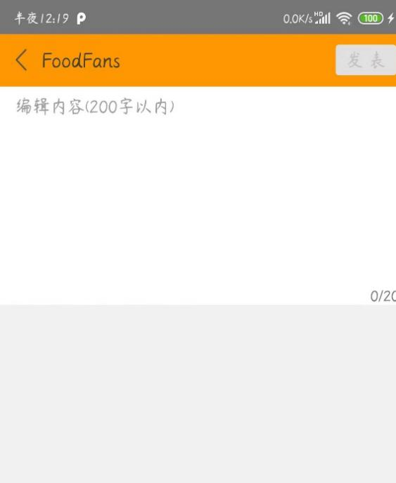

## 3.4登录注册界面

### 3.4.1界面简介

用户进入APP需先进入登录界面进行登录操作，未注册用户可通过注册按钮，进入注册界面，注册信息将会记录入数据库。

### 3.4.2界面展示

## 

## 3.5用户中心界面

### 3.5.1界面简介

在“我的”栏中用户可查看用户中心。用户中心展示用户头像，用户昵称，用户可点击“我的收藏”栏进入收藏界面查看已收藏菜品。“浏览记录”界面展示用户菜品浏览记录。

### 3.5.2界面展示

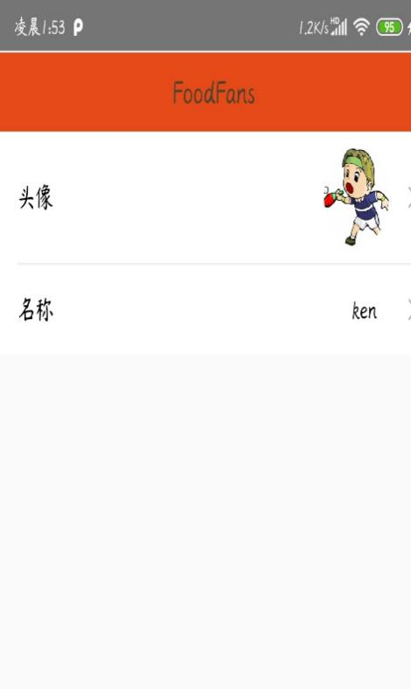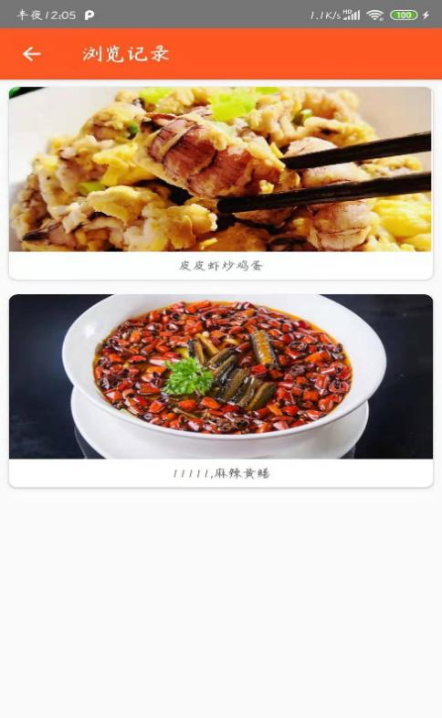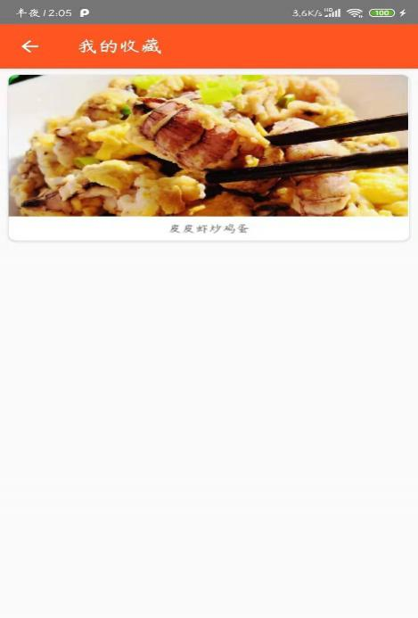

# 接口设计

## 4.1接口列表

|  |  |  |
| --- | --- | --- |
| Service API List | | |
|  | Service | Service API |
| 1 | Get a list of course information from server | [/queryArticle](http://localhost:8080/elearn/courses) |
| 2 | Get a course information from server by courseID | [/queryVideo](http://localhost:8080/elearn/courses/%7bcourseID%7d) |
| 3 | Get a list of course materials by courseid | [/followAuthor](http://localhost:8080/elearn/courses/%7bcourseid%7d/materials) |
| 4 | Get all course teachers by courseid | [/followAuthorVideo](http://localhost:8080/elearn/courses/%7bcourseid%7d/teachers) |
| 5 | Get course avatar by courseid | [/praiseArticle](http://localhost:8080/elearn/courses/%7bcourseid%7d/photo) |
| 6 | Get video/audio material by material id | [/praiseVideo](http://localhost:8080/elearn/materials/%7bmid%7d/media) |
| 7 | Get image/file material of a course by its material id | [/dashangArticle](http://localhost:8080/elearn/materials/%7bmid%7d/file) |
| 8 | Get VideoFrame image of a video material by material id | [/dashangViedo](http://localhost:8080/elearn/materials/%7bmid%7d/videoframe) |
| 9 | Get a teacher's photo by teacher id | [/putArticle](http://localhost:8080/elearn/teachers/%7btid%7d/photo) |
| 10 | Get a teacher's photo by teacher id | [/putViedo](http://localhost:8080/elearn/teachers/%7btid%7d/photo) |
| 11 | Get a teacher's photo by teacher id | [/commentArticle](http://localhost:8080/elearn/teachers/%7btid%7d/photo) |
| 12 | Get a teacher's photo by teacher id | [/commentViedo](http://localhost:8080/elearn/teachers/%7btid%7d/photo) |
| 13 | Get a teacher's photo by teacher id | [/search_articles](http://localhost:8080/elearn/teachers/%7btid%7d/photo) |
| 14 | Get a teacher's photo by teacher id | [/home](http://localhost:8080/elearn/teachers/%7btid%7d/photo) |
| 15 | Get a teacher's photo by teacher id | [/homehot](http://localhost:8080/elearn/teachers/%7btid%7d/photo) |
| 16 | Get a teacher's photo by teacher id | [/allArticle](http://localhost:8080/elearn/teachers/%7btid%7d/photo) |
| 17 | Get a teacher's photo by teacher id | [/allViedo](http://localhost:8080/elearn/teachers/%7btid%7d/photo) |
| 18 | Get a teacher's photo by teacher id | [/allGoods](http://localhost:8080/elearn/teachers/%7btid%7d/photo) |
| 19 | Get a teacher's photo by teacher id | [/buy](http://localhost:8080/elearn/teachers/%7btid%7d/photo) |
| 20 | record list | [/query](http://localhost:8080/elearn/teachers/%7btid%7d/photo) |
| 22 | Get a teacher's photo by teacher id | [/putsale](http://localhost:8080/elearn/teachers/%7btid%7d/photo) |
| 23 | Get a teacher's photo by teacher id | [/login](http://localhost:8080/elearn/teachers/%7btid%7d/photo) |
| 24 | Get a teacher's photo by teacher id | [/register](http://localhost:8080/elearn/teachers/%7btid%7d/photo) |
| 25 | Get a teacher's photo by teacher id | [/find_password](http://localhost:8080/elearn/teachers/%7btid%7d/photo) |
| 26 | Get a teacher's photo by teacher id | [/change_password](http://localhost:8080/elearn/teachers/%7btid%7d/photo) |
| 27 | Get a teacher's photo by teacher id | [/update_userHeadPicture](http://localhost:8080/elearn/teachers/%7btid%7d/photo) |
| 28 | Get a teacher's photo by teacher id | [/update_userinfo](http://localhost:8080/elearn/teachers/%7btid%7d/photo) |
| 29 | Get a teacher's photo by teacher id | [/get_email_code](http://localhost:8080/elearn/teachers/%7btid%7d/photo) |
| 30 | Get a teacher's photo by teacher id | [/update_userHeadPicture](http://localhost:8080/elearn/teachers/%7btid%7d/photo) |
| 31 | Get a teacher's photo by teacher id | [/add_friend](http://localhost:8080/elearn/teachers/%7btid%7d/photo) |
| 32 | Get a teacher's photo by teacher id | [/delete_friend](http://localhost:8080/elearn/teachers/%7btid%7d/photo) |
| 33 | Get a teacher's photo by teacher id | [/get_personal_friends](http://localhost:8080/elearn/teachers/%7btid%7d/photo) |
| 34 | Get a teacher's photo by teacher id | [/add_collection_video](http://localhost:8080/elearn/teachers/%7btid%7d/photo) |
| 35 | Get a teacher's photo by teacher id | [/add_history_video](http://localhost:8080/elearn/teachers/%7btid%7d/photo) |
| 36 | Get a teacher's photo by teacher id | [/remove_collection_video](http://localhost:8080/elearn/teachers/%7btid%7d/photo) |
| 37 | Get a teacher's photo by teacher id | [/add_collection_article](http://localhost:8080/elearn/teachers/%7btid%7d/photo) |
| 38 | Get a teacher's photo by teacher id | [/add_history_article](http://localhost:8080/elearn/teachers/%7btid%7d/photo) |
| 39 | Get a teacher's photo by teacher id | [/remove_collection_article](http://localhost:8080/elearn/teachers/%7btid%7d/photo) |
| 40 | Get a teacher's photo by teacher id | [/send_message](http://localhost:8080/elearn/teachers/%7btid%7d/photo) |
| 41 | Get a teacher's photo by teacher id | [/get_personal_info](http://localhost:8080/elearn/teachers/%7btid%7d/photo) |
| 42 | Get a teacher's photo by teacher id | [/get_personal_collection](http://localhost:8080/elearn/teachers/%7btid%7d/photo) |
| 43 | Get a teacher's photo by teacher id | [/get_personal_publish](http://localhost:8080/elearn/teachers/%7btid%7d/photo) |
| 44 | Get a teacher's photo by teacher id | [/get_personal_history](http://localhost:8080/elearn/teachers/%7btid%7d/photo) |

## 4.2接口说明

|  |  |  |
| --- | --- | --- |
| Service API List | | |
|  | Service API | Method |
| 1 | [/queryArticle](http://localhost:8080/elearn/courses) | POST |
| 2 | [/queryVideo](http://localhost:8080/elearn/courses/%7bcourseID%7d) | POST |
| 3 | [/followAuthor](http://localhost:8080/elearn/courses/%7bcourseid%7d/materials) | POST |
| 4 | [/followAuthorVideo](http://localhost:8080/elearn/courses/%7bcourseid%7d/teachers) | POST |
| 5 | [/praiseArticle](http://localhost:8080/elearn/courses/%7bcourseid%7d/photo) | POST |
| 6 | [/praiseVideo](http://localhost:8080/elearn/materials/%7bmid%7d/media) | POST |
| 7 | [/dashangArticle](http://localhost:8080/elearn/materials/%7bmid%7d/file) | POST |
| 8 | [/dashangViedo](http://localhost:8080/elearn/materials/%7bmid%7d/videoframe) | POST |
| 9 | [/putArticle](http://localhost:8080/elearn/teachers/%7btid%7d/photo) | POST |
| 10 | [/putViedo](http://localhost:8080/elearn/teachers/%7btid%7d/photo) | POST |
| 11 | [/commentArticle](http://localhost:8080/elearn/teachers/%7btid%7d/photo) | POST |
| 12 | [/commentViedo](http://localhost:8080/elearn/teachers/%7btid%7d/photo) | POST |
| 13 | [/search_articles](http://localhost:8080/elearn/teachers/%7btid%7d/photo) | POST |
| 14 | [/home](http://localhost:8080/elearn/teachers/%7btid%7d/photo) | GET |
| 15 | [/homehot](http://localhost:8080/elearn/teachers/%7btid%7d/photo) | GET |
| 16 | [/allArticle](http://localhost:8080/elearn/teachers/%7btid%7d/photo) | GET |
| 17 | [/allViedo](http://localhost:8080/elearn/teachers/%7btid%7d/photo) | GET |
| 18 | [/allGoods](http://localhost:8080/elearn/teachers/%7btid%7d/photo) | GET |
| 19 | [/buy](http://localhost:8080/elearn/teachers/%7btid%7d/photo) | GET |
| 20 | [/query](http://localhost:8080/elearn/teachers/%7btid%7d/photo) | GET |
| 22 | [/putsale](http://localhost:8080/elearn/teachers/%7btid%7d/photo) | POST |
| 23 | [/login](http://localhost:8080/elearn/teachers/%7btid%7d/photo) | POST |
| 24 | [/register](http://localhost:8080/elearn/teachers/%7btid%7d/photo) | POST |
| 25 | [/find_password](http://localhost:8080/elearn/teachers/%7btid%7d/photo) | POST |
| 26 | [/change_password](http://localhost:8080/elearn/teachers/%7btid%7d/photo) | POST |
| 27 | [/update_userHeadPicture](http://localhost:8080/elearn/teachers/%7btid%7d/photo) | POST |
| 28 | [/update_userinfo](http://localhost:8080/elearn/teachers/%7btid%7d/photo) | POST |
| 29 | [/get_email_code](http://localhost:8080/elearn/teachers/%7btid%7d/photo) | POST |
| 30 | [/update_userHeadPicture](http://localhost:8080/elearn/teachers/%7btid%7d/photo) | POST |
| 31 | [/add_friend](http://localhost:8080/elearn/teachers/%7btid%7d/photo) | POST |
| 32 | [/delete_friend](http://localhost:8080/elearn/teachers/%7btid%7d/photo) | POST |
| 33 | [/get_personal_friends](http://localhost:8080/elearn/teachers/%7btid%7d/photo) | GET |
| 34 | [/add_collection_video](http://localhost:8080/elearn/teachers/%7btid%7d/photo) | POST |
| 35 | [/add_history_video](http://localhost:8080/elearn/teachers/%7btid%7d/photo) | POST |
| 36 | [/remove_collection_video](http://localhost:8080/elearn/teachers/%7btid%7d/photo) | POST |
| 37 | [/add_collection_article](http://localhost:8080/elearn/teachers/%7btid%7d/photo) | POST |
| 38 | [/add_history_article](http://localhost:8080/elearn/teachers/%7btid%7d/photo) | POST |
| 39 | [/remove_collection_article](http://localhost:8080/elearn/teachers/%7btid%7d/photo) | POST |
| 40 | [/send_message](http://localhost:8080/elearn/teachers/%7btid%7d/photo) | POST |
| 41 | [/get_personal_info](http://localhost:8080/elearn/teachers/%7btid%7d/photo) | GET |
| 42 | [/get_personal_collection](http://localhost:8080/elearn/teachers/%7btid%7d/photo) | GET |
| 43 | [/get_personal_publish](http://localhost:8080/elearn/teachers/%7btid%7d/photo) | GET |
| 44 | [/get_personal_history](http://localhost:8080/elearn/teachers/%7btid%7d/photo) | GET |

# 项目总结

本项目实现了所有预期功能，菜品推荐，菜品分类搜索，菜品评价体系，用户中心等功能运行正常，项目顺利结束。